Prescribers
*
From the Special menu choose Prescribers
We were going to title this section “Managing Prescibers” but we all know that's not possible
When you are in dispensary mode, issuing items to a patient allows you to add a prescriber. This menu item allows you to set up your list of prescribers.
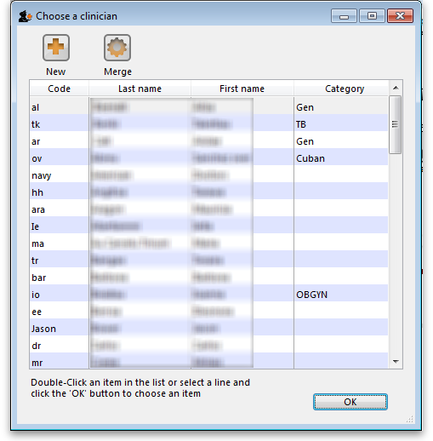
To add a new prescriber, click the “New” button.
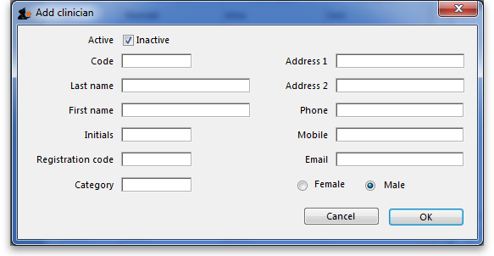
Add a code for the presciber. You can use the code quickly to look upthe prescriber when dispensing.
Other fields are fairly self-explanatory. Note that the code, first name and last name can all be used for looking up prescribers when dispensing.

Initials
The text you put in the “Initials” field will print on dispensary labels.

Active status
If you have a prescriber that is no longer used, you can change their status to “inactive” and the prescriber will not show in the choice list when dispensing. Inactive prescribers will still show when you choose Special > Show Prescibers…
We suggest you might want to add a “Miscellanous Prescribers” item to the list, and use this if you have a lot of prescribers whose prescriptions you only dispense infrequently.

Category
This field can be used to group prescribers together, and can then be used to filter prescribers when producing a transaction report.

Merge prescribers
This item from the Special menu is used to merge two prescribers, where the same prescriber has inadvertently been entered twice. You are shown a window like this:
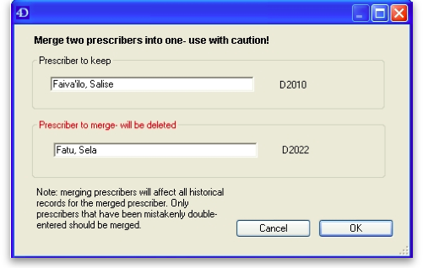
Enter the two prescriber names by entering the start of their surname or their code, and then pressing Tab . The top prescriber is the one who will be kept. The lower prescriber will be deleted.
Once you have entered the two names, check the details are correct, and then click OK. You will be warned one last time, and then the operation will be completed.
All transactions that recorded the deleted prescriber will now show the name of the prescriber that was kept.

Import prescribers
For information on the procedure for importing a file containing your prescribers see Importing prescribers
<note>To continue to the next section of the mSupply® user guide click here</note>

