27.03. Help > About mSupply
You can get a lot of useful information about your current installation in the Help>About mSupply menu item. When you choose this from the menus, this window opens:
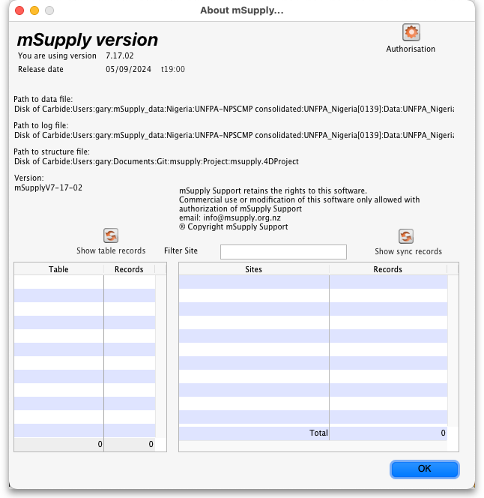
- mSupply version: This sectio, at the top, shows tyou wnat version of mSupply you are running and when it was released (date and time).
- Paths: This section shows you some of the paths to the datafile and the log file in case you need to track them down.
- Show table records button: If you click on this button
- Show sync records button:
- Authorisation button:

Previous: 27.01. Support and mSupply Up-to-Date program | | Next: 28. Frequently Asked Questions

