14.09. Exporting items, exporting items and stock

Exporting items
Choosing Export items from the File menu allows you to export all of the stock items in your data file to a text file; see Importing Items where the format of the text file is described under 'Field order for the text file'. This allows you to import them to another data file. When you select this option you will see this dialog box:
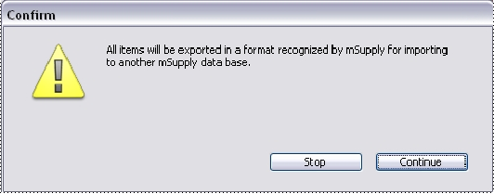
Click continue to carry on. The standard file dialog window for your operating system will appear, allowing you to select a file name and location to save the text file.

Exporting items and stock
This option, like the previous one, allows you to export all of the stock items in your data file together with the stock on hand; all details are exported, including batch numbers and expiry dates. The output is a text file, in a format recognisable by mSupply so that you can later import it to another data file.
Previous: Exporting invoices Next: Exporting names

