23.10. Siglofa integration
mSupply has an interface with Siglofa, a variant of OpenLMIS.

Settings
Choose File > Preferences from the menus and click on the Siglofa tab on the left hand side:
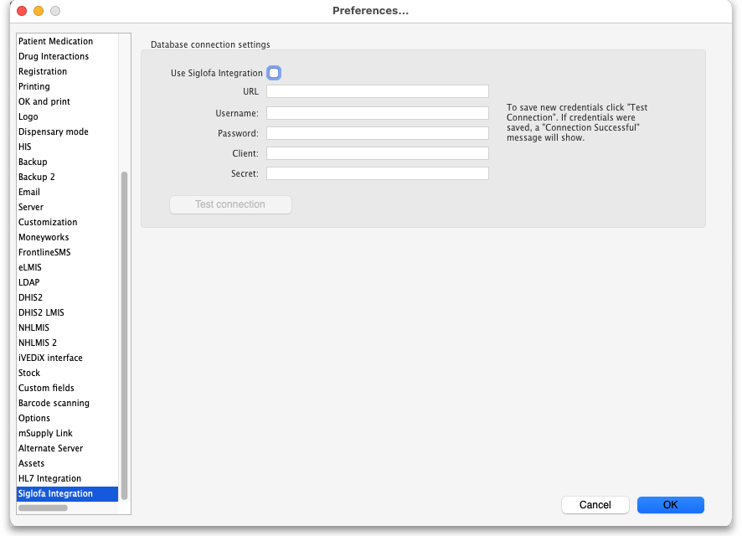
- Use Siglofa integration: if checked then the other fields will be unlocked and mSupply will do what is described in the What it does section below.
- URL: Enter the URL, including the port number if any, of the Siglofa application.
- Username: The username mSupply should use to connec to Siglofa.
- Password: The password mSupply should use to connect to Siglofa.
- Client: The client name used to connect to Siglofa, provided by the Siglofa team.
- Secret: The password to go with the Client name, as provided by the Siglofa team..
- Test connection button: click this to test the connection to the Siglofs server when all the details above have been entered. mSupply will tell you whether it was able to successfully connect to Siglofa.

What it does
If the Use Siglofa integration checkbox is checked and the connection details result in a successful database connection, a scheduled task is started which will:
- Once a day check Siglofa for new requisitions. If there are any then they will be retrieved and added as suggested status customer (response) requisitions in the central warehouse store in mSupply.
- Once a day check mSupply for customer invoices created from Siglofa requisitions that have not been created as orders in Siglofa. If there are any then:
  - Create an order matching the customer invoice in Siglofa.
  - If the order has been created successfully then send the requisition lines as the order's lines.
- A separate scheduled task will check for successfully created orders where sending the order lines has failed. If it finds any it will send the appropriate requisition lines to the order.

Previous: 23.09. iVEDiX integration | | Next: 24. Data Tables and Fields

