4.01.12. Order options tab
Back to Item Details window
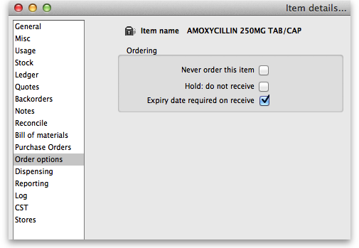
Never order this item: If you have items that are “one-offs” or have been discontinued, use this check box to stop them appearing in orders.
Hold: do not receive: If this check-box is checked, you can not receive this item into the store you are currently logged into. This can be useful if you have changed to using a different item, and you do not want people to accidentally use the redundant item.
Expiry date required on receive: When this is checked, you will be unable to receive this item unless an expiry date is entered for it. Therefore it is best to check this box for items that will always have an expiry date such as oral medicines and to leave it unchecked for items that will never have an expiry date such as surgical instruments.
- You will be warned if you try to add or edit an item on a goods receipt or a supplier invoice that has no expiry date entered. Also, you will not be able to finalise a goods receipt that contains items which have no expiry date entered.
Previous: 4.01.12. Items - Purchase orders tab | | Next: 4.01.14. Items - Dispensing tab

