4.01.11. Purchase orders tab
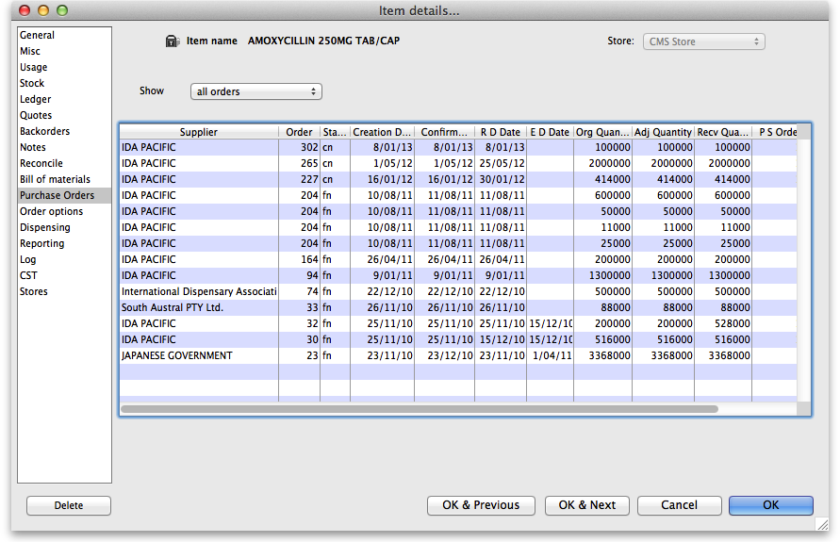
- The Show drop down list beside allows filtering the display of Purchase Orders according to their status - All, Suggested, etc. -
- If you double-click a row the Purchase order will be opened in a new window.

