4.01.09. Reconcile tab
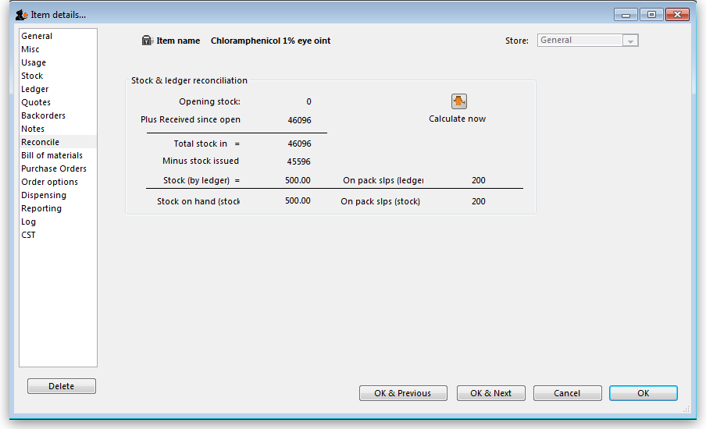
Clicking the Reconcile button will give a summary of usage.
It is useful for checking mSupply® is working as it should be! If you get an error here it is most likely due to your using mSupply® when a power failure occurred. In multi-user versions we are able to provide you with a log file that will allow you to incorporate transactions entered even if a power failure has occurred. In normal use, with a UPS, mSupply® will automatically save data and you will not see an error here.

