Custom Data
*
Custom data allows you to add data to mSupply that doesn't naturally fit into one of the existing fields.
- Choose Special > Show custom data… to show the list of custom data sets.
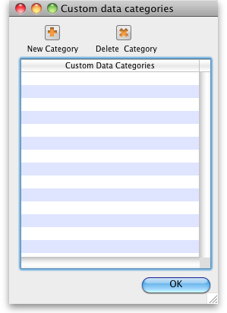

Setup Fields
- Click New
- This window is shown:
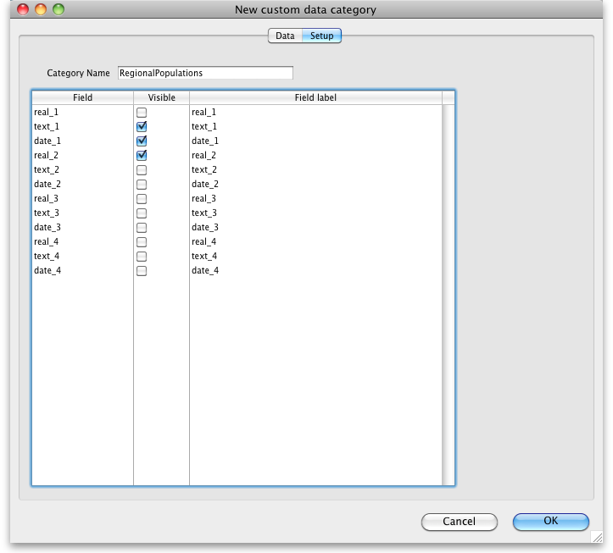
- For our example, we're going to record population in several regions each year, so we need
  - A real number field to store the population number
  - A text field to store the region name
  - A date field to store the year
- We've labelled the data set RegionalPopulations
- To change the field names, click once on the name, and then wait a second or two and click again- now it is editable:
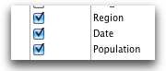

Adding data
- Click the data tab then click New
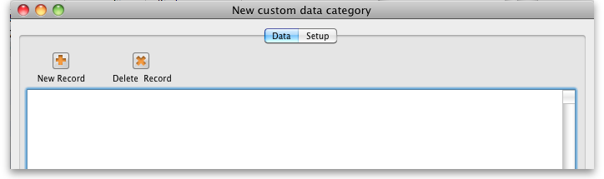

Using data in reports
- You can extract data by using the following method in a pagepro report
- custom_value_get(“data_set”;“field_to_query”;“search_value”;“field_to_return”;→“variable_to_return”)
  - “data_set” is the name of the data set. e.g. "RegionalPopulations"
  - field_to_query is the internal name of the field “text_1” , “Text_2”, “real_2”, “date_7”
  - “search_value” is the value you're looking for in “field_to_query”
  - “field_to_return” is the field name of the value to return
  - “variable_to_return” is a pointer to the variable that will contain the data returned.
- Sound too complicated? We usually build these reports for clients, but this documentation is for the technically minded who want to build their own.
Previous: Virtual stores Next: [[admin:diagnostics|Backup

