25.03. Remote synchronisation
Updated: mSupply Version 4.0.3 Updated: mSupply Version 4.12
mSupply's remote synchronisation allows mSupply running stores on local servers to send data to a central mSupply server for combined reporting.

Synchronisation explained
It's like this:
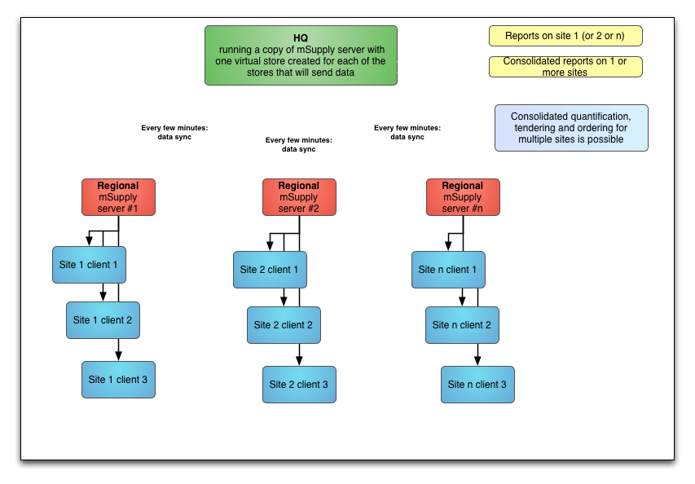

Definitions
- The central server (a.k.a. sync server) is a central mSupply server. In any given setup, there will only be one central server, which must be running a web server, and it is responsible for:
  - aggregating the store data from all stores ⇒ enables centralised reporting, and a real-time backup
  - controlling how all of the stores sync with each other
  - routing transfers from one store to another
  - running the mSupply dashboard
- The primary server is a central mSupply server. In any given setup, there will only be one primary server, and it is responsible for:
  - controlling the central data which is common across all stores e.g. names and items
  - controlling the store records themselves, their preferences and visibility in stores ⇒ all stores exist on the primary
- A remote site is any mSupply server, single-user standalone mSupply, or mSupply mobile instance which is not the central server:
  - the syncing process is initiated from each remote site on a schedule, and pushes its own updated records to the central server first, before pulling any updated records from the central server
- For most installations, the central server and the primary server are one and the same, but for mirrored systems (see Mirrored sync below for details) they can be different - in that case the primary server is just a special case of a remote site.
- The central server, and all of the remote sites are collectively referred to as sync sites.
- Each sync site has a unique ID and connection parameters (IP address, username and password), setup in the synchronisation preferences, along with a list of the other sync sites with which it can send/receive synchronisation data. These settings are complicated, easy to get wrong, and so should only be modified by Sustainable Solutions.
- Multiple copies of the same store can exist across multiple sites (see Store setup below for details), but they can have different store types on different sites:
  - each store is active on a single sync site, and that is where its own store data can be added, edited, and deleted
  - a collector copy of a store is a full read-only copy of the store - these will usually exist on the central server, and can be logged into and reported on
  - a transfer copy of a store is a partial read-only copy of the store - these exist on other sites where the store is visible, to enable the site's active store(s) to send and receive transfers
- To preserve data integrity, and to avoid potential clashes where more than one sync site tries to modify the same record, only one sync site can edit/update any specific type of data. There are some special cases (see Data types below for details), but most data falls into one of the following types:
  - Central data (a.k.a. system data) is common to all stores (e.g. suppliers, customers, items) - this can only be edited or imported on the primary server, and changes are synced to all sites
  - Central store data is data related directly to a store record e.g. store preferences and visibility - this can only be edited or imported on the primary server, but changes are only synced to the site where the store is active
  - Store data (e.g. transactions, stock, locations) can only be edited or imported on the sync site where the store is active, and changes are only synced to any site where the store exists as a collector copy (e.g. the central server)
  - Patient data (e.g. patients, PMR records, insurance policies) can only be edited on the sync site where its home store is active, and changes are synced to any site where the patient is visible

Mirrored sync
In a mirrored synchronisation system, the primary server becomes a remote site with responsibility for editing the central data:
- this remote site doesn't need to be online all the time, so that it can run operations for its own active stores and still be able to administer centrally-controlled data, without being a bottleneck for sync
- the central server (especially if it's in the cloud) can be always online and available for remote access to reports and the dashboard, and for processing and routing of sync data
The typical use case is where a site in a country that has the responsibility for administering items has poor internet (typically the Central Medical Stores), so that it either can't run the central server locally and/or can't reliably connect to a cloud-based central server. By using mirrored sync, this site retains authority, but a reliable central server elsewhere ensures that synchronisation with other sites is not hindered and that external users can still access the dashboard.

Store setup
Stores to be synced will exist as separate instances of the same store on more than one sync site:
- on the primary server - the store itself and its non-sync related preferences are editable ⇒ all stores must exist on the primary server
- on the central server - the store's sync preferences are editable ⇒ all stores must exist on the central server
On a mirrored sync system, the store must be created first on the primary server. It will then sync to the central server, where the store's site can then be assigned and its sync preferences configured.
- store data (e.g. store transactions, stock) can only be edited on a single sync site - the site on which the store is defined as active. This is controlled on the central server by the store preferences on the Synchronisation tab for each virtual store on each sync site:
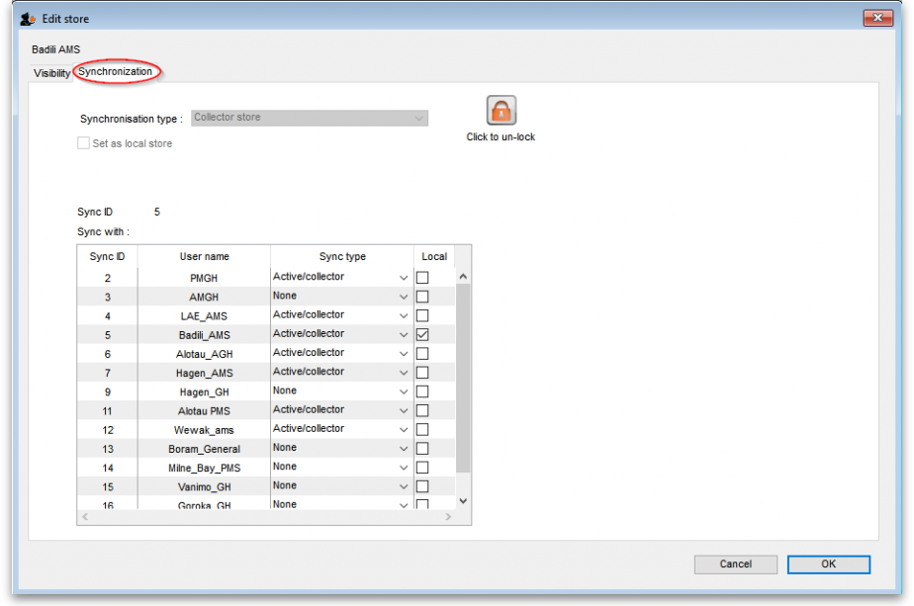
Synchronisation type drop down list: Shows the sync type of the current store. Will be editable on the central server if you have unlocked it using the Click to unlock button.
Click to unlock button: Click it to enter the unlocking password to enable you to edit the settings on this tab.
Set as local store checkbox: Will be editable on the central server if you have unlocked it using the Click to unlock button. If checked, this will change the store's Sync ID to be that of the current site and will uncheck any of the elements in the Local column in the Sync with table.
Include transactions in sync checkbox: Only affects dispensary stores, as transactions are always synced otherwise. If checked for a dispensary store, this will also sync prescriptions and related dispensary data. This preference is turned on by default for all stores and is permanently disabled (regardless of whether you have unlocked the settings using the Unlock button). It can only be turned off by Sustainable Solutions.
Resync patient records when store is saved checkbox: If checked, when you click the OK button to save the store's settings, the central server will resend all the patient records for patients visible in the store to the active copy of the store. Along with that, all the other dispensary related information that is required will be sent, such as patient medication records, prescribers, abbreviations, insurance providers, directions, prescription categories and diagnoses. Quite a lot of information
Sync ID field: Displays the sync ID of the current store so that you can see which one in the table below you're talking about! The store's sync ID should almost always be the ID of the site where the store is active.
Sync with table: Shows the other sites in your sync setup that the current store will sync with. Also defines what relationship those other store instances have to your current one and therefore what records need to be sent to that site from the instance of the current store on the current site. Will be editable (only on the central server) if you have entered the password using the Click to unlock button. Checking any checkbox in the Local column will set the store's Sync ID to be that of the selected row, and will uncheck any others as well as the Set as local store checkbox.
This setting is a bit confusing, but it does work to understand it as 'whatever the sync type of the store is on that site'.
If your version of mSupply server is pre 3.50, after changing sync settings for a store you will have to restart the mSupply application on the primary server for the changes to be applied.
- Once a store has been set up (see the relevant parameters below), item and store visibility for the store needs to be set up on the central server - see Virtual stores, Controlling item visibility.
- To do that, once you log in to the central server, you need to switch to the new store - see Switching store
- To do that, you need to have permission to log in to it - see Managing users (It's a good thing this doesn't happen often! )
These settings are necessarily complex and should only be modified by Sustainable Solutions, after discussions to agree on the configuration which is the best fit for requirements.

Store sync types
Each store in a synchronised system needs to have a sync “type” as described here.

Active
A store whose sync type is active means that the store-specific data can be edited (added, edited, deleted) on the sync site where you are logged into this store.

Collector
A store whose sync type is collector means that the store-specific data can not be edited on this sync site. The store on this server receives all store data from an active store on another sync site i.e. it is a replica of a corresponding active store on another sync site. This means that the store can be examined and reports generated on this sync site.

Transfer
A store whose sync type is transfer is similar to the collector type except that the store on this sync site is used only as a vehicle for receiving stock transfers or requisitions from other stores on the same sync site and passing them on to the corresponding store on other sync sites. It doesn't receive any other store data (such as stock lines). That is, it is not a replica of an active store, and should not be used as such. The store can not be examined or have reports generated on this sync site. The benefit of a transfer store over a collector store is that transfer stores require less data to be synced between servers.

Store sync-with options
Updated: mSupply Version 4.12
The Store 'sync-with' options control which store-specific synchronisation data gets sent to the other sync sites which are linked to that sync site:

None
A value of None means that this store doesn't sync with the corresponding store on the selected sync site. That is, there is no instance of this store on that sync site. If a store is not visible to any stores active on the selected sync site, or its visibility settings are changed so that it becomes invisible to all active stores on the selected sync site, then it will automatically be set to None for that site.

Active/collector
A value of Active/collector means that store-specific data edits, including any edits to the core store data, are synced to the corresponding store instance on the selected sync site. The store instance on the selected sync site will normally be of type active (on the site with matching sync ID) or collector (on any other sites). A store cannot be a collector on the selected sync site unless it is visible to at least one other store which is active on the site.

Transfer
A value of Transfer means that any updates to the core store data, or any stock transfers or requisitions into that store, are synced to the corresponding store instance on the selected sync site. No other transactions or other store-specific data will be transferred. The store instance on the selected sync site will normally be of type transfer. If a store's visibility settings are changed so that it becomes visible to any other stores which are active on the selected sync site, then it will automatically be set to Transfer for that site.
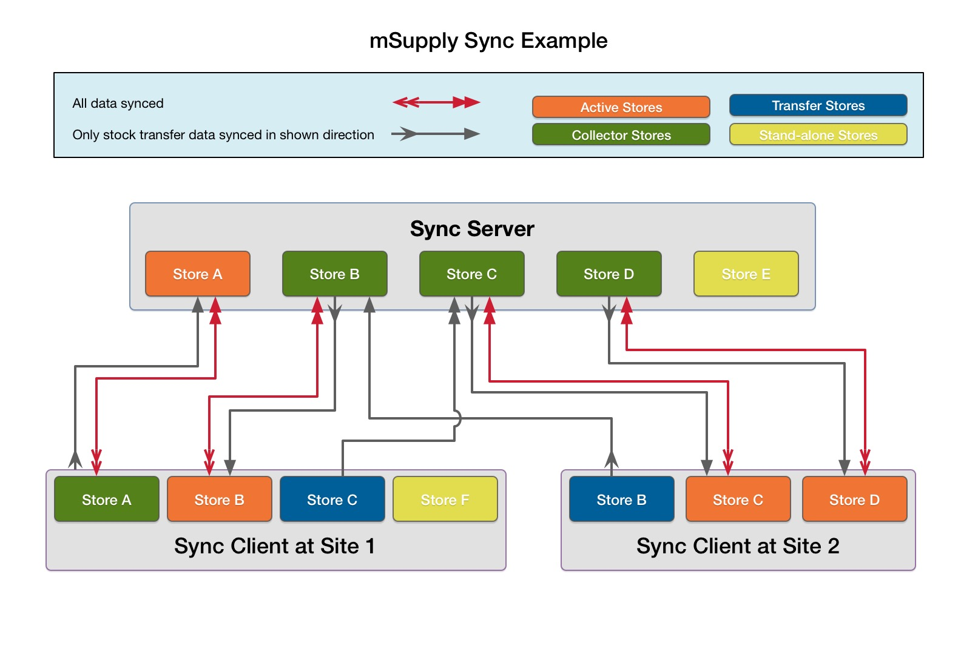
- In a standard (non-mirrored) setup, the sync server is both the primary server and the central server
- In a mirrored setup, the sync server is only the central server - the primary server is one of the remote sites, except that:
  - it can also control central data
  - like the central server, all stores must exist

Store A
An example of a store on the sync server which needs to also be reportable on another remote site.
Store A exists as an Active store on sync server and as a Collector store on remote site 1:
- On sync server store-specific data for this store can be entered. It can also receive stock transfers or requisitions from other stores active on the same sync site (sync server). This data is then synced to remote site 1.
- On remote site 1 store-specific data for this store cannot be entered. However, the store can receive stock transfers or requisitions from other stores active on the same sync site (remote site 1). These will be synced to sync server.
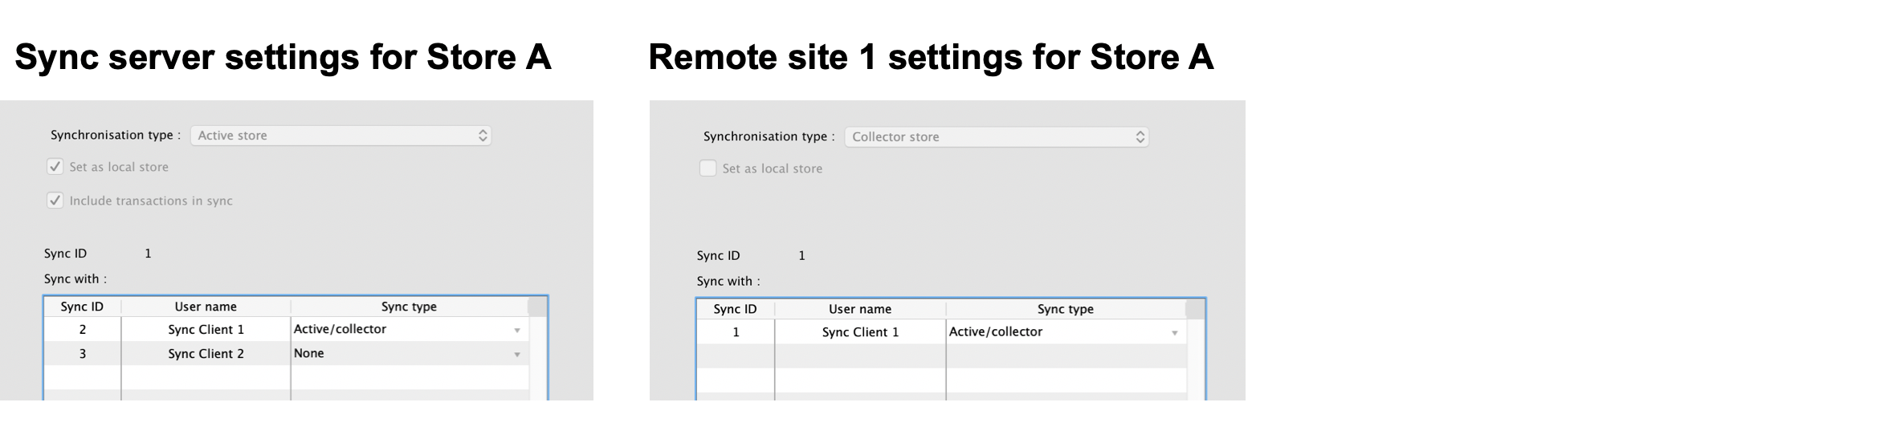

Store B
An example of a store on one remote site which needs to receive stock transfers from a store on another remote site.
Store B exists as a Collector store on sync server, an Active store on remote site 1, and a Transfer store on remote site 2:
- On remote site 1, store-specific data for this store can be entered. It can also receive stock transfers or requisitions from other stores active on the same sync site (remote site 1). This data is then synced to sync server.
- On sync server, store-specific data for this store cannot be entered. However, it can receive stock transfers or requisitions from other stores active on the same sync site (sync server). These are then synced to remote site 1.
- On remote site 2, store-specific data for this store cannot be entered, and is not synced from sync server. However, it can receive stock transfers or requisitions from other stores active on the same sync site (remote site 2). These are then synced to sync server, and then to remote site 1.
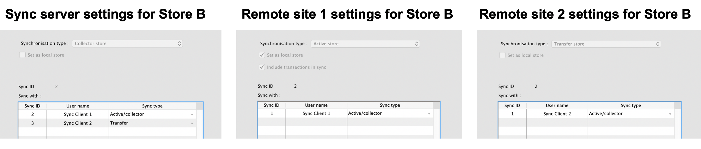

Store C
Another example of a store on one remote site which needs to receive stock transfers from a store on another remote site.
Store C exists as a Collector store on sync server, an Active store on remote site 2, and a Transfer store on remote site 1:
- On remote site 2, store-specific data for this store can be entered. It can also receive stock transfers or requisitions from other stores active on the same sync site (remote site 2). This data is then synced to sync server.
- On sync server, store-specific data for this store cannot be entered. However, it can receive stock transfers or requisitions from other stores active on the same sync site (sync server). These are then synced to remote site 2.
- On remote site 1, store-specific data for this store cannot be entered. However, it can receive stock transfers or requisitions from other stores active on the same sync site (remote site 1). These are then synced to sync server, and then to remote site 2.
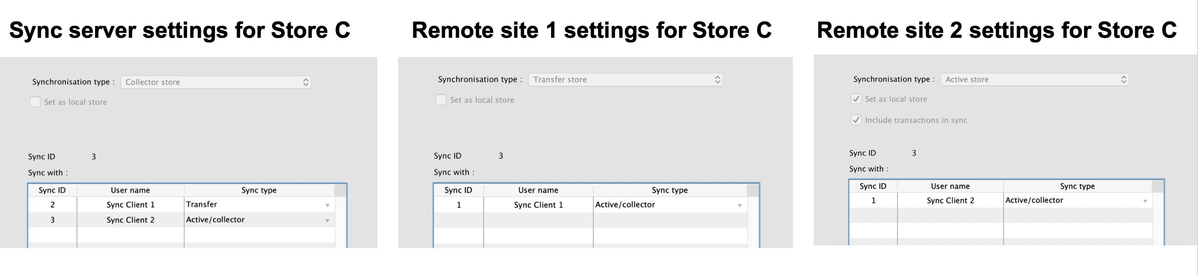

Store D
An example of a store on a remote site which needs to also be reportable on the sync server.
Store D exists as an Active store on remote site 2 and as a Collector store on sync server:
- On remote site 2, store-specific data for this store can be entered. It can also receive stock transfers or requisitions from other stores active on the same sync site (remote site 2). This data is then synced to sync server.
- On sync server, store-specific data for this store cannot be entered. However, it can receive stock transfers or requisitions from other stores active on the same sync site (sync server). These are then synced to remote site 2.
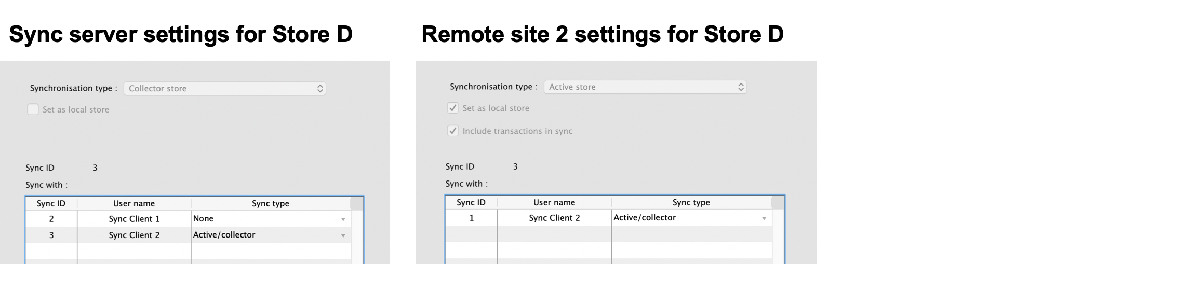

Store E
An example of a store which is local to the sync server only.
Store E exists only on sync server (and primary server, if different):
- On sync server, store-specific data for this store can be entered. It can also receive stock transfers or requisitions from other stores active on the same sync site (sync server). This data is not synced anywhere.
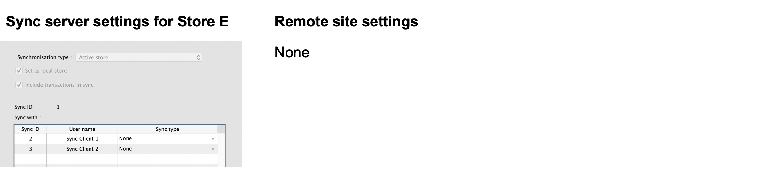

Store F
An example of a store which is local to a single remote site.
Store F exists on remote site 1, but it must also exist on the sync server (and primary server, if different) as a Transfer store, so that it can be centrally managed:
- On remote site 1, store-specific data for this store can be entered. It can also receive stock transfers or requisitions from other stores active on the same sync site (remote site 1). This data is not synced anywhere.
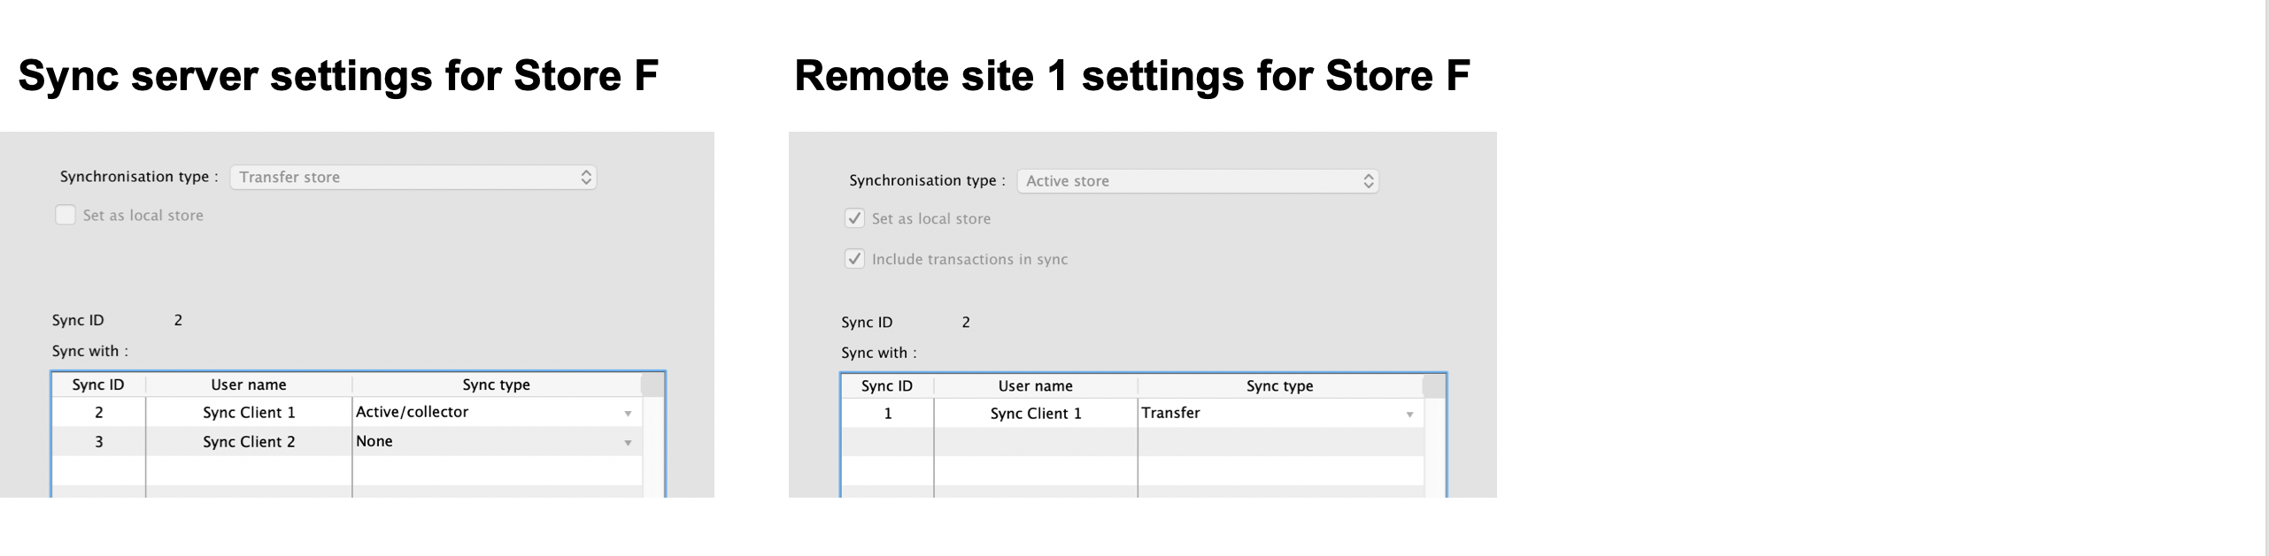

Data types
The table below is a high-level summary of the different data types:
- Central data can only be edited or imported on the primary server, and changes are synced to all sites
- Central store data can only be edited or imported on the primary server, but changes are only synced to the site where the store is active
- Store data can only be edited or imported on the sync site where the store is active, and changes are only synced to any site where the store exists as a collector copy (e.g. the central server)
- Patient data can only be edited on the sync site where its home store is active, and changes are synced to any site where the patient is visible
- Local data can be edited or imported on any site but doesn't sync anywhere
- Sync data can only be edited on the central server but doesn't directly sync anywhere
- Message data can be edited on any site and syncs according to the sending/receiving store
- There are also a number of special cases, which don't easily fit into a single type
Data | Type | Notes
Items | Central | Including item-related data e.g. item categories, units
Names (except patients) | Central | Including name-related data e.g. name categories, contacts
Merging of items, units and names (except patients) | Central
Groups and departments | Central
Item master lists | Central
Budgets and accounts | Central
Transaction categories | Central
Purchase order categories | Central
Location types | Central
Regimens and indicators | Central
Abbreviations and item directions | Central | Dispensary data
Custom reports | Central
Sites and sync-related preferences | Sync | Changes on the central server indirectly update related records on remote sites
Messages and sync records | Message | Depends on sending and receiving store (which can be blank)
Stores and non sync-related store preferences | Central store
Visibility of items and names (except patients) | Central store
Visibility of existing patients and prescribers | Central store
Visibility of new patients and prescribers | Patient | New visibility records sent to central server
Patients and prescribers | Patient | Including patient-related data e.g. PMR, insurance policies
Merging of patients and prescribers | Patient
Customer stock history and requisitions | Store
Locations | Store
Merging locations | Store
Stock and stocktakes | Store
Transactions, payments and prescriptions | Store | Including other transaction-related data e.g. inventory adjustments, backorders, builds
Goods received | Store
Indicator values | Store
Purchase orders | Store | Except for centralised procurement or supervisor-mode ordering
Purchase orders (centralised) | Central Store
Preferences (non-store) | Local | Except for a few special cases which are explicitly synced
User permissions | Local
Existing users | Local
New users | Store | New user records sent to central server

Stores
These are a special case:
- changes to the store record itself (all except the Synchronisation tab) are allowed only on the primary server, and then propagate on to any other sync sites as determined by the “syncs with” settings for that store on the sync server (i.e. to any other sync sites where “syncs with” is not None)
- the store's sync preferences (the Synchronisation tab) are controlled on the sync server
- a store should only ever be Active on one sync site at a time (usually on the site where it is Local)

Centralised procurement
If this preference is switched on in the primary site, then purchase orders can be entered for any store on the primary, regardless of its sync type (i.e. not just for active stores).
If it is switched on in a satellite, then purchase orders cannot be entered for any store on the satellite, even if it is active.
When this preference is changed on the primary, the change will propagate to all the satellites as well.
It is still possible to edit the preference on the remote (e.g. to allow local procurement for stores active on that site), but if that is the case, then the related permissions for purchase orders for those stores on the primary will need to be disabled manually in order to prevent purchase orders for those stores being editable on both sites.

Dispensary data

Prescriptions
By default, prescriptions and any other operations in dispensary mode which affect stock levels are not synced to the sync server, unless the Include transactions in sync option is enabled in the store sync preferences, as these can potentially generate a lot of sync traffic and there is usually no need for the central users to have this level of detail - the same site will usually have another store which supplies the dispensary and its transactions will be synced, and that's usually enough to infer usage for the dispensary store.
If this preference is switched off in a dispensary store on a remote site, the following data will not be synced back to the central sync server:
- Transactions (including backorders, builds etc.)
- Prescriptions
- Stock and stocktakes
If the preference is switched on, all of the store's transaction & stock data will be synced to the sync server.

Patients
Patients in mSupply are a special kind of customer, but for the purposes of synchronisation, we need to treat them differently - more like store-specific data rather than system data. This is because patient data is often locally controlled rather than centrally.
Since mSupply v4.09, patients have a home store, initialised either according to the store they were created in, or according to their most recent prescription. Patients and their related data (patient medication records, repeats, insurance policies) can only be edited in an active dispensary store on the same home site where their home store is active.
Patients and their related data records will be synced to the primary server, and forwarded on to any other site which has an active/collector store in which the patient is visible. Prescriptions will be allowed in dispensary stores on any of those sites, except for repeats which can only be processed in dispensary stores on the patient's home site.
Newly created patients will also be made visible in any other dispensary stores on the home site, depending on the store's visibility preferences. Subsequently, patient visibility is controlled from the primary server in the same way as for other name (customer & supplier) records.

Other dispensary data
Abbreviations, item directions, insurance providers and patient event types are treated as a special kind of system-specific data i.e. they are editable on the primary, but only synced to sites having at least one active dispensary store.
Prescribers are also treated as a special kind of store-specific data, like patients i.e. they are editable in any active dispensary store on their home site, synced back to the primary server, and shared with dispensary stores on other sites where they've previously prescribed.

Transferring patients/prescribers to a different home store
Watch this space…

Transfers
Transfers occur when there are two stores involved in a transaction, and includes stock transfers, requisitions (from a mobile store) and internal requisitions (from another desktop store). In a syncing system, very often these two stores are not active on the same site, so there has to be extra processing to ensure that both halves of the transaction are synced to both the initiating store/site and the responding store/site.
Both stores need to exist on both sites, and usually the initiating store is a transfer store on the responding site, and vice-versa. As of mSupply v3.83, unless both stores are active on the same site (in which case, everything can be done locally), the bulk of the processing is done on the central sync server when it detects the initiating half of a transfer transaction. In simple terms, the logic is something like this:
- when the sync server detects the initiating half of a transfer transaction
  - it creates the responding half of the transaction, but with a dummy invoice/serial number of -1
  - it ensures that both halves of the transaction are synced to both initiating and responding sites
- when the responding site receives the responding half of the transaction
  - it assigns the next invoice/serial number for the store and sends that back to the sync server
  - it also creates a log message for the initiating half of the transaction and sends that back to the initiating site via the sync server
- any subsequent changes to the initiating half of the transaction (usually very limited in scope) on the initiating store/site will be synced back to the sync server (according to the normal sync rules)
- any subsequent changes to the responding half of the transaction on the responding store/site will be synced back to the sync server (according to the normal sync rules)

Stock transfers
- This is where the customer in a customer invoice is another store
- The initiating half of the transaction is where the customer invoice is finalised in the initiating store/site
- The responding half of the transaction is a supplier invoice (on hold by default) in the responding store/site

Mobile requisitions
- This is where the supplier in a supplier (aka request) requisition is another store
- The initiating half of the transaction is where the supplier requisition is finalised on mobile
- The responding half of the transaction is a response requisition in the responding store/site
  - this shows up as a customer requisition on mobile if the responding store is active on another mobile site
  - or as a response requisition if the responding store is active on a desktop site
    - the user can create one or more customer invoices to fulfil the requistion
    - these customer invoices (when finalised) will generate corresponding supplier invoices back in the initiating store as stock transfers

Internal requisitions
- This is where the supplier in a purchase order is another store, and is a two-stage process
- The initiating half of the first transaction is where the purchase order is confirmed in the purchase order store/site (i.e. where the purchase order is editable)
  - if centralised procurement is enabled, this will be the primary site, otherwise it will be the normal initiating store/site (i.e. where the purchase order's store is active)
- The responding half of the first transaction is a customer invoice in the responding store/site
- The initiating half of the second transaction is where the customer invoice is finalised in the responding store/site
  - note that adding extra customer invoice lines before the invoice is finalised will create corresponding new goods received lines
- The responding half of the second transaction is a goods received record in the initiating store/site (i.e. where the purchase order's store is active)
- If centralised procurement is enabled:
  - the received quantities for the original purchase order lines will be updated on the primary whenever the corresponding goods received lines are received there (and forwarded from there to the initiating store/site)
  - when the primary receives any subsquent updates to goods received lines from the initiating store/site, it will update the quantities in the corresponding purchase order lines
- If centralised procurement is not enabled, the received quantities for the original purchase order lines will be updated in the initiating store/site when it receives the goods received lines from the primary

Reporting
- On the sync server if you login in supervisor mode, you can then run reports on one or more stores. The reports can answer questions such as:
  - How much stock on hand of item X (or all items) are there at each location?
  - What is the value of stock on hand across the whole system?
  - How many of item X is being used each month at each location?
- When the synchronisation system is turned on, a new Special > Users report… > Sync report… menu item is available. Choosing this will create a report showing the last time each of your sync stores connected to the central sync server. Those that connected more than a month ago will be highlighted in red.

Requirements
- A license from Sustainable Solutions to use the web server module and the synchronisation module on the primary server.
- Internet at each sync site. This doesn't have to be on all the time for each satellite server, but at least an hour or so per day or per week (depending on the transaction volume and the speed and latency of the internet, and how often you need primary server data updated). Obviously, the internet needs to be on at the primary server at the same time.

How to tell if synchronisation is happening

The Manual Sync Button
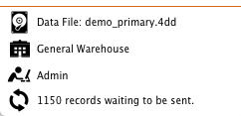
If you click the “2 arrows” icon it will initiate an immediate synchronisation and update the statistics on the number of records remaining as sync progresses.

On a remote site
If there are queued sync records, there will be a message at the bottom left of the navigator which shows the number of sync records in the queue. If this is not going down, there may be an entry in the log.

On the sync server
- Choose Help > About mSupply
- At the bottom left of the window there is a list of tables and the number of records in each table.
- Scroll the list to near the bottom, and you will see the number of records in the sync_out table.
  - If the number is zero, your copy of mSupply is up to date
  - If the number is growing from day to day, there are possible reasons:
    - you need to provide more internet time or faster internet
    - there may be a problem that needs the attention of Sustainable Solutions. Before contacting us, make sure the internet is connected for an hour, and see if the number is decreasing or not.
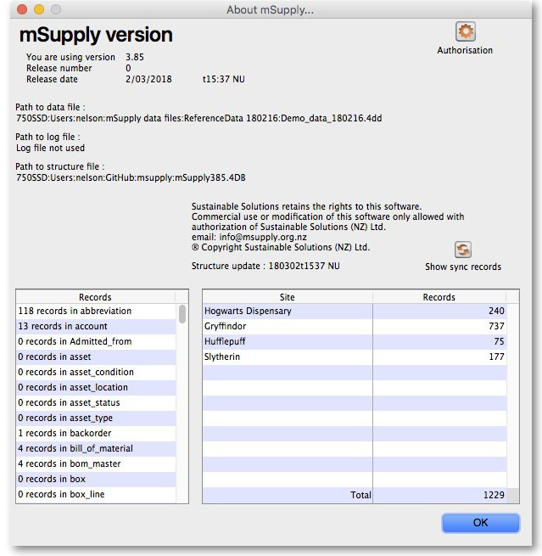

Setting up or extending a sync system
This is not something for end users to configure, so it's best left to the experts at Sustainable Solutions! However, there is a lot of preparation ground work that can be done beforehand:
- Decide how to configure your server(s)
  - for a local combined primary and sync server:
    - can your local server be online most of the time (it is more important that the internet to be reliable than for it to be fast)?
    - have you a fixed external IP address?
    - can you open the necessary firewall ports to allow access to the local server from outside?
  - for a combined primary and sync server on the cloud:
    - is your local internet fast enough to support remote access to the cloud server to administer system data?
  - otherwise, it's better to have a separate local primary server and cloud sync server
- Do a site survey for all the proposed stores
  - how is the internet access and local network?
  - how reliable is the power supply?
  - is there a suitable location for mSupply?
- Decide which version of mSupply is best for each store - don't worry, this can be changed later and licenses can be transferred
  - central primary server: mSupply server with local clients (depending on the number of users)
  - central sync server: mSupply server with local clients (depending on the number of users) and web server
  - multi-user central/district warehouse/busy dispensary: mSupply server with local clients (depending on the number of users)
  - single-user store/quiet dispensary (desktop): mSupply single-user desktop
  - small store/clinic: mSupply mobile
- Decide on the heirarchy of the stores you want to include
  - which stores supply other stores?
  - can stores which have the same supplying store transfer to each other, or just with the supplying store?
  - for dispensary stores, do you need to see prescription details on the central server
- Decide on the users for each site and their roles/permissions

Movings stores and sites
Misconfiguring of store or site settings can corrupt data across the synchronisation system. This should only be done by someone trained to do so and with guidance from the mSupply team

Moving a store from the central server to a new sync site
Use the site wizard.

Moving a store from one sync site to another
To move a store from one site to another means to make it not Active on the 'From' site, and Active on the 'To' site. By default, mSupply will leave the store configured to maintain a full Collector copy on the 'From' site with all the associated sync traffic. This is not normally desired. Except for this process of determining which site a store is Active on, all sync settings are governed by store visibility settings.
This process involves editing store sync settings which is dangerous. Editing store sync settings must happen on the central server and is restricted (by password) to Sussol technicians. Please consult with us to coordinate this. The full process is documented here for your information.
- A mobile site can only have one Active store.
- Therefore, only one of the stores on a 'From' desktop site can be moved to a single mobile site.
- If another Active store on the 'From' desktop site needs to be moved to a mobile site, then it will need to be moved to another sync site, mobile or desktop.
If the 'To' store is the central server, then this same procedure applies
- Ensure that both the 'From' site and the 'To' site (only relevant if it is a desktop site) are fully synchronised.
- Ensure that no new data is entered on either site until the move is complete. Therefore, best to plan for this process to happen overnight or over the weekend…
- On the central server, Special > Stores > double-click the store that is being moved > Synchronisation tab > Click to un-lock, enter code to edit (Sussol technicians only)
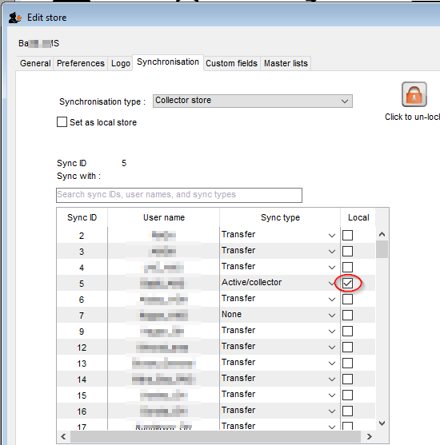
- If the 'To' site is a desktop site that already exists, then make the store Active on the 'To' site by finding the 'To' site in the list and click on the Local checkbox.
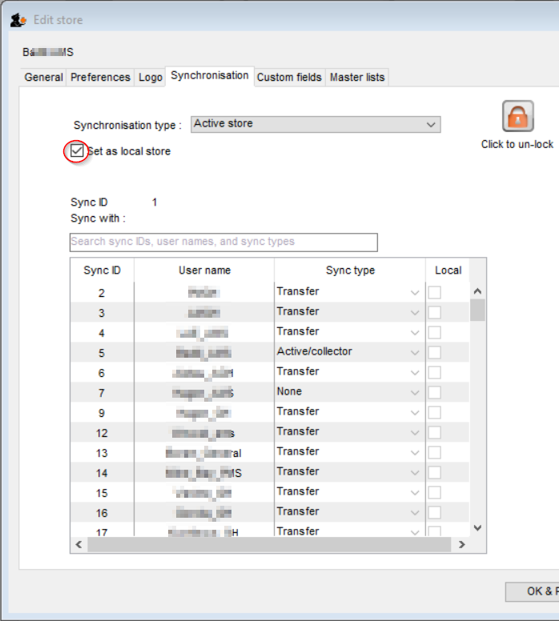
- If the 'To' site is the central server, or doesn't yet exist, make the store Active on the central server by clicking on the Set as local store checkbox
- Unless you are sure that you want a full Collector copy of the store to be maintained on the 'From' site (not normally desired), change the sync type for this store on the 'From' site to Transfer.
- Click OK to save changes
- Click OK to exit the stores list
- If the 'To' site is the central server, skip to step 12.
- If the 'To' site doesn't yet exist, use the site wizard to create the new sync site and move the store to it.
  - If the 'To' site is a new desktop site, create the data file using Sync site export and Sync site import.
  - If the 'To' site is a mobile site, then get it initiated as discussed in Installation of mSupply Mobile APK and initiation.
The store should now be visible on the on the new site, in which case it is safe to operate it.
- If the 'To' site is an existing desktop site, then code needs to be run on the Central server to generate sync out records for that store - refer Sussol internal reference.
- If the 'From' site now has no stores on it (it was a mobile site or a desktop site with only one store on it), then the sync site can be safely deleted. (Sussol technicians only)
If you are moving the store from Mobile to Desktop of vice versa, this process will not change the site type. As of 2020-10-02 this must be done by Sussol technicians only by use of the record browser.

Previous: 26.02. Reminders | | Next: 26.03. Transaction Status & Type Codes

