FrontlineSMS
*
If you use FrontlineSMS for sending information to mSupply via SMS messages (using mobile phones), this is the page where you enter all the settings.
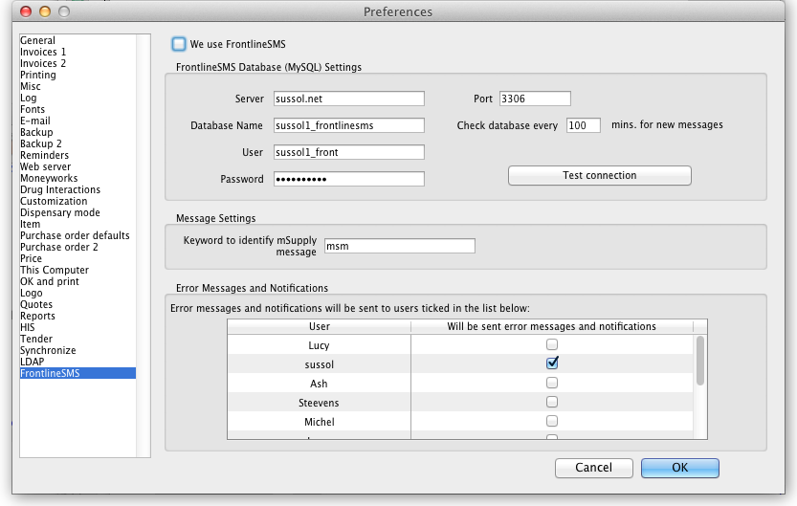
The settings and what they mean are as follows:

We use FrontlineSMS:
Checking this makes mSupply periodically check the FrontlineSMS database for messages that have been sent to mSupply. If this checkbox is left unchecked, mSupply ignores all the settings on this page and will not check the FrontlineSMS database for new messages.

FrontlineSMS database (MySQL) settings
To use FrontlineSMS with mSupply, FrontlineSMS must be configured with a MySQL database. In this section you tell mSupply the details of this database to enable it to connect to it and retrieve new messages.
Server: The name of the server hosting the FrontlineSMS database. You can enter the server's name e.g. myserver.mydomain or its IP address.
Database name: The name of the FrontlineSMS database. This is the name it was given when it was created in MySQL.
User: The username that mSupply will use to log into this database.
Password: The password that goes with the username above.
Port: The port that the database is served at on the host. If you leave this blank, mSupply will set it to the default port used by MySQL (3306).
Test Connection Button: This button will test the connection to the FrontlineSMS database using the settings above. You should click it after you've entered all the settings or when you change any of them. It will tell you whether the settings allowed mSupply to connect to the database.
<note important>If a connection cannot be made to the database when clicking the Test Connection button, the exact error message returned from MySQL is stored in the log. To view it go to Special > View log. This can be very handy when trying to figure out why you can't connect to the FrontlineSMS database.</note>
Check database every x mins. for new messages: This is the time in minutes between checks of the FrontlineSMS database for new messages. The minimum is 2 minutes and if you don't set it, this is the value it will be given.

Message settings
Keyword to identify mSupply message: This is what mSupply looks for at the very beginning of an SMS message received by FrontlineSMS to identify it as one that it must process. Can be made up of any alphanumeric characters. Keep it short and unique - not something that will appear at the beginning of any SMS messages not intended for mSupply.

Error Messages and Notifications
Because the process is otherwise silent, mSupply needs to notify users when a new message has been processed or if errors occur in the process (e.g. a message is missing some information). mSupply will email such error messages and notifications to the users ticked in the list in this section. The list contains all users in the system and you must select at least one of them.
Back to: General preferences

