Assigning item codes automatically
- If you want item codes to be assigned automatically, check the checkbox on the items tab of the preferences (File > Preferences > Items
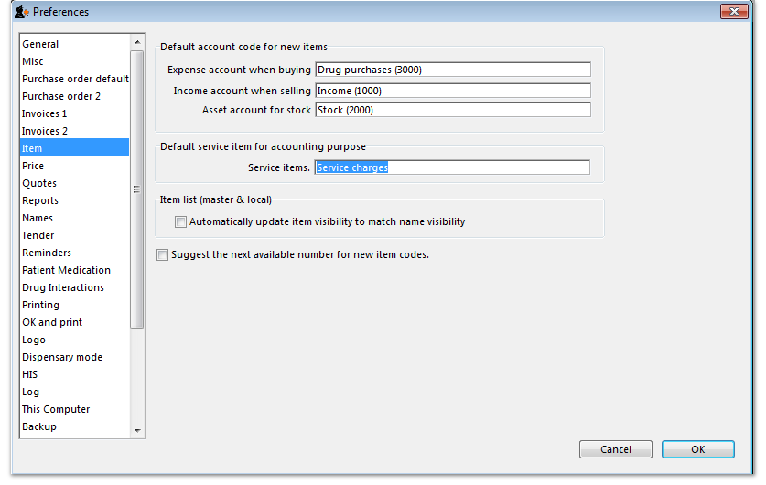Preferences window:item tab

