The PagePro Report Editor
*
- As of version 3.03 mSupply includes the PagePro report editor.
- The graphic below shows the standard mSupply pick list being edited in PagePro.
- It gives almost unlimited customisation possibilities for forms and reports.
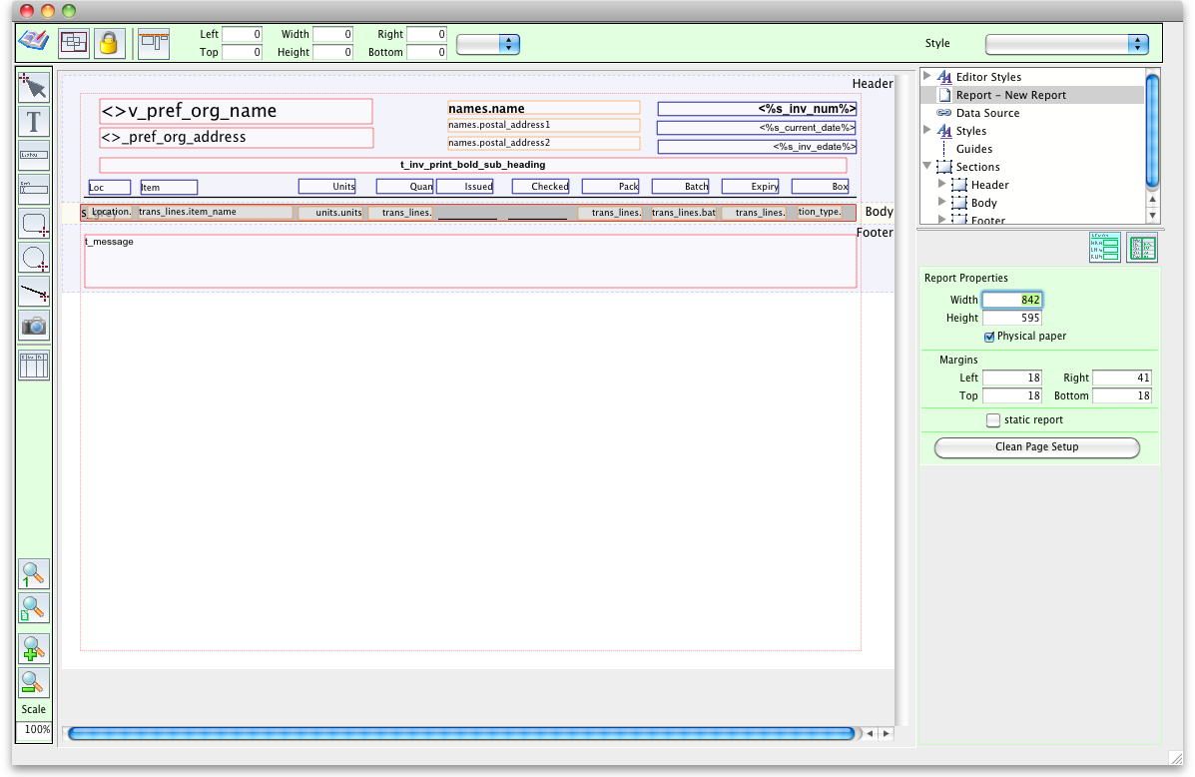
More on Pagepro coming soon
Previous: Report Basics Next: Custom Reporting Tutorial

