18.03. Adding suppliers to a tender and inviting responses
To add suppliers to the tender, click the Choose suppliers and enter responses tab to open this window, where the suppliers to whom your tender will be sent may be added, or subsequently deleted:
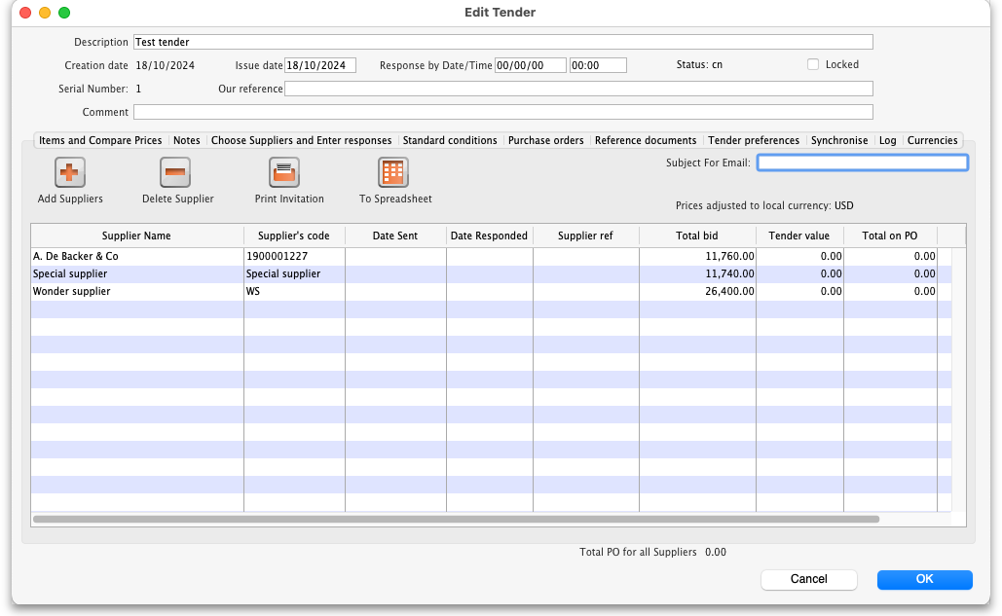
Note: The RTM Link column in the table shows whether the selected supplier has been linked with the Remote Tender Module (checked if it has)
To add suppliers to the list, click the Add Suppliers button.
A list of all suppliers is shown:
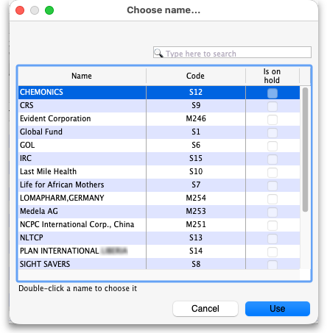
You can add multiple suppliers by holding down the control key (command key on Mac) and clicking on those suppliers you wish to add. Once you have selected a supplier or suppliers, click the Use button to add them to the list. To create a new supplier, click the New button.
Once suppliers are added, they will appear in the list:
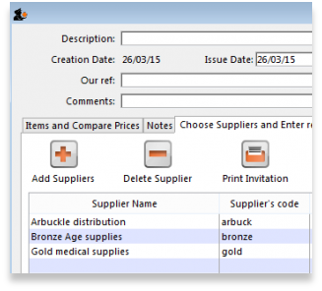
Double clicking a supplier will open a window for adding and editing quotations - see below.
It there are any suppliers listed that do not have a tick in the RTM Link column and you intend to publish the tender to the web, you will need to contact mSupply Support: support@msupply.org.nz

Deleting a supplier
Highlight the supplier you wish to remove from the tender, then click the Delete supplier button. This will remove the supplier from the tender - it will not delete the supplier from mSupply. Note: you cannot remove a supplier from a finalised tender, or if the supplier has quoted on one or more tender items. If you want to remove a supplier for which quotations have been entered, delete the quotations first, then you can delete the supplier.

Inviting quotations from suppliers

Print Invitation letter
Clicking this button prints an “Invitation to tender” letter ready for dispatch to the highlighted supplier; the letter includes all the items, quantities, etc. as specified in the tender. The default date for a response is one month after the date of the letter, but this can be amended to a date of your choosing.
If the default format of the Invitation letter does not meet your requirements, please let us know and we will customise the print format to meet your individual requirements.

Email Selected button
Clicking this button produces email documents for each of the highlighted suppliers. A PDF document (the same as the printed document) is produced, attached to an email and stored in the email queue. This option will work only if you have entered email addresses for the chosen suppliers.
Whichever method you choose, you will be given the option for the Date sent field to be filled automatically with today's date.

To Spreadsheet
Clicking this button opens your spreadsheet application, with all the items and quantities required on the tender document already entered in appropriate rows and columns. This may be saved and sent to the supplier along with the tender letter. Appropriate columns are already in place for suppliers to enter their responses.
Previous: 18.02. Standard tender conditions | | Next: 18.04. Adding supplier responses to a tender

